KENDRIYA VIDYALAYA NO 1 RAIPUR C G

 **CYBER CAFÉ MANAGEMENT**

SUBMITTED TO: SIMPA KHARAGWANSHI

SUBMITTED BY :TANMAY KUMAR SAHU

(12623133)

T V S N VAIBHAV

(12623135)

EXTERNAL INTERNAL PRINCIPAL SINGNATURE SIGNATURE SIGNATURE

INDEX

|  |  |  |
| --- | --- | --- |
|  |  |  |
| 01 | ACKNOWLEGEMENT | 3 |
| 02 | CERTIFICATE | 4 |
| 03 | DECLARATION | 5 |
| 04 | INTRODUCTION | 6 |
| 05 | REQUIREMENT | 7 |
| 06 | CASE STUDY | 8 |
| 07 | FUTURE SCOPE | 9 |
| 08 | FUNCTION USED | 11 |
| 09 | SOURCE CODE | 12 |
| 10 | OUTPUT | 16 |
| 11 | BIBLIOGRAPHY | 17 |

Acknowledgements

I would like to express my sincere gratitude to my ***CS mentor MRS . SIMPA KHARAGWANSHI PGT(CS)*** For her vital support, guidance and encouragement, without which this project would not have come forth. I would also like to express my gratitude to the other staff of the Department of CS for their support during the making of this project.

CERTIFICATE

THE PROJECT REPORT ENTITLED “***CYBER CAFE MANAGEMENT’’*** SUBMITTED BY ***TANMAY SAHU & T V S N VAIBHAV*** OF CLASS 12 A FOR THE ***C.B.S.E SENIOR SECONDARY EXAMINATION CLASS XII*** OF COMPUTER SCIENCE AT ***KENDRIYA VIDYALYA NO 1 RAIPUR C G*** HAS BEEN EXAMINED .

***SINGNATURE OF EXAMINER***

Declaration

I HERE BY DECLARE THAT THE PROJECT WORK ENTILED **CYBER CAFÉ MANAGEMENT** SUBMITTED TO **SIMPA KHAREGWANSHI PGT CS KENDRIYA VIDYALAYA NO 1 RAIPUR CG** IS PREPARED BY US (TANMAY AND VAIBHAV).ALL THE CODING ARE RESULT OF US PERSONAL EFFORTS

**TANMAY KUMAR SAHU**

**T V S N VAIBHAV**

Introduction

The cyber café management system clears the doubts of the customers .

It helps the owner of the cyber café in maintaining a solid record of the customers and ensures the bill payment .

It also helps in providing feedbacks of our cyber cafe

REQUIREMENT

THE PURPOSE OF THE PROJECT IS TO BUILD AN APPLICATION PROGRAM TO REDUCE THE MANUAL WORK FOR MANAGEMENT OF THE CHARGES,COMPUTERS.

EDITING ,ADDING AND UPDATING OF RECORDS IS IMPROVED WHICH RESULTS IN PROPER RESOURCE MANAGEMENT.

***CASE STUDY***

* ENABLES THE STUDENTS TO LEARN TO UTILIZE MODERN SOFTWARE TOOLS
* STUDENTS START TO DEMONSTRATE ABILITY TO CONDUCT A RESEARCH OR APPLIED COMPUTER SCIENCE PROJECT REQUIRING WRITING AND PRESENTATION SKILLS
* THEY ARE ABLE TO WRITE EFFECTIVE PROCEDURAL CODE TO SOLVE SMALLTO MEDIUM SIZED PROBLEMS

FUTURE SCOPE

* The project is made in the hopes of making India a super power through making softwares like these .
* The project will guide the customers in the right way and also the owners so they can be benefitted .
* It will become the building block of another more sophisticated yet simple software which will lead the charts in the future markets

***SOFTWARE REQUIREMENT***

* WINDOW OS
* PYTHON
* SQL

***FUNCTION USED***

* 1 CONNECT () – FOR DATABASE & TABLES CREATION
* 2 CURSOR () – TO EXECUTE MYSQL QUERIES
* 3 COMMIT () – TO EXECUTE CURRENT TRANSACTION
* 4 FETCHALL () – TO FETCH ALL THE ROWS
* 5 FETCHONE () – TO FETCH ROW ACCORDING TO QUERY

***SOURCE CODE***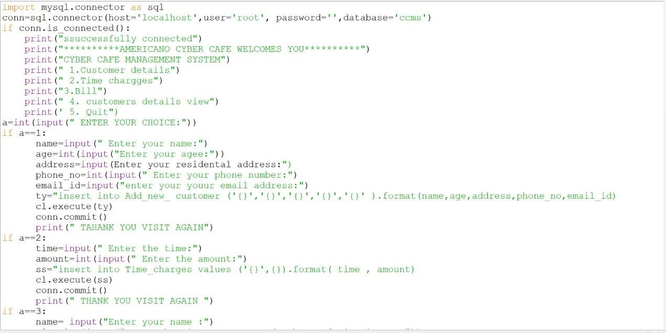

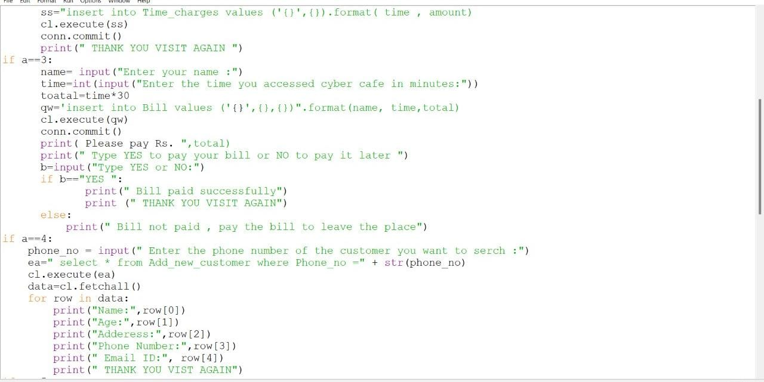

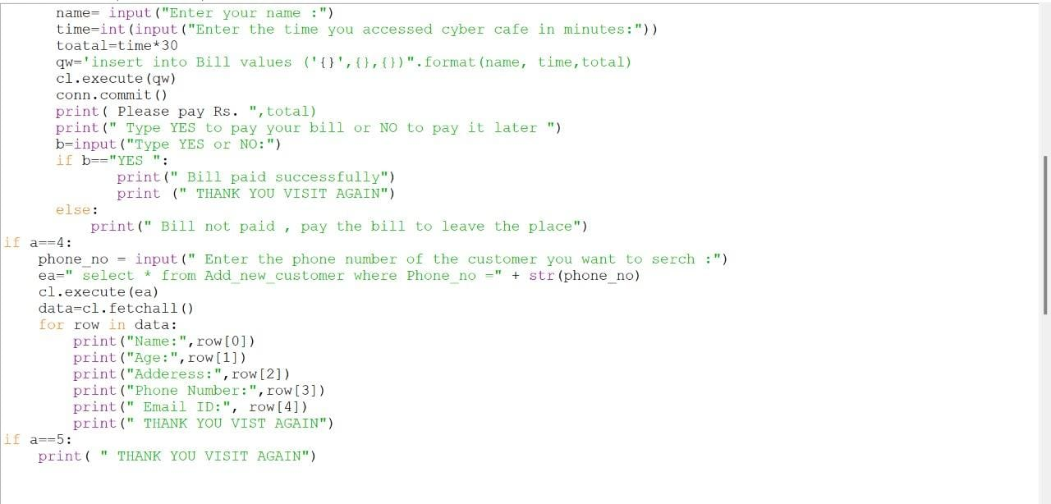

OUTPUT

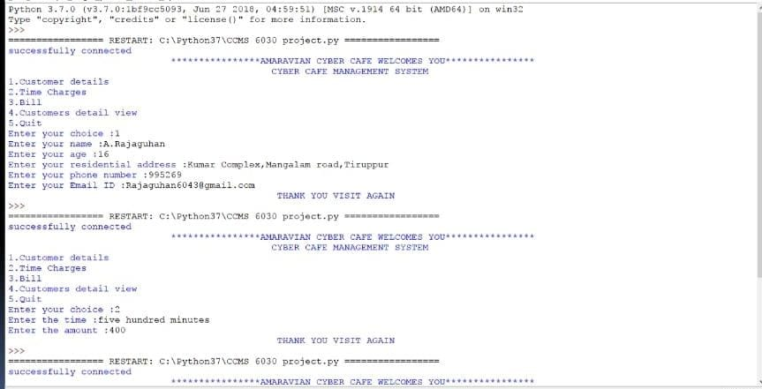

**BIBLIOGRAPHY**

CS PROJECT ON CYBER CAFÉ MANAGEMENT BY

TANMAY KUMAR SAHU

Python.mykvs

Python4csip.com

Sumita arora

